**Write a query to retrieve all the movies released after the year 2005**.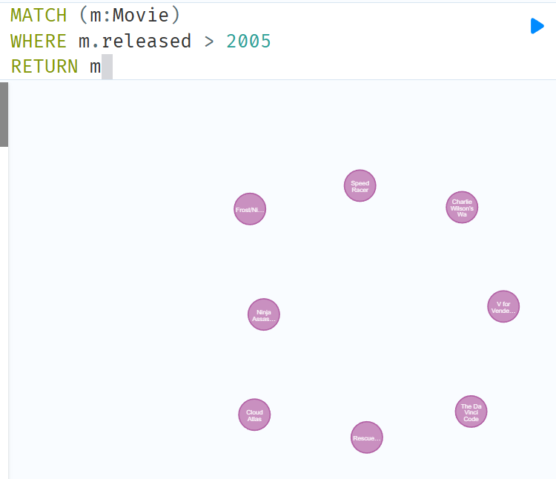

**Write a query to return the count of movies released after the year 2005. (Hint: you can use the COUNT(m) function to return the count)**

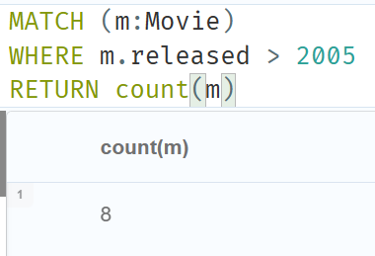

**Query to get all the people who acted in a movie that was released after 2010.**

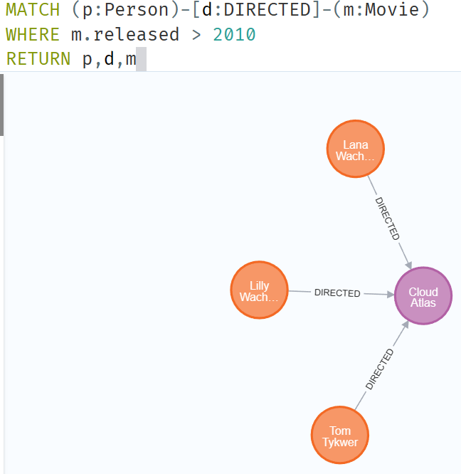

**will return only Person Nodes (limiting to 20 items) while**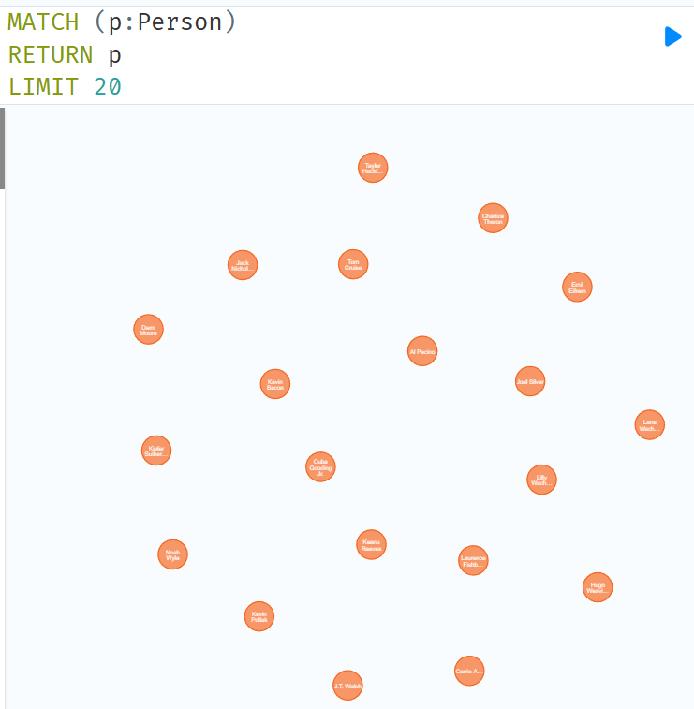

**will return all kinds of nodes (limiting to 20 items).**

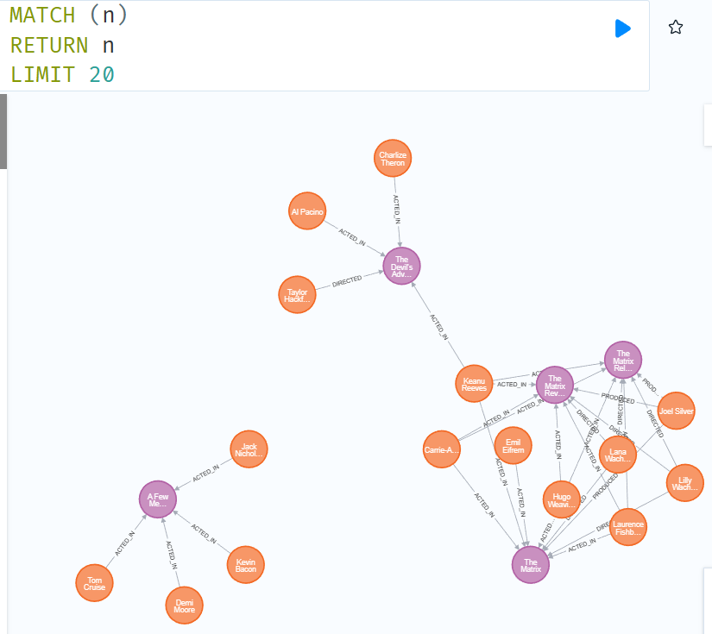

**Write a query to get name and born properties of the Person node.**

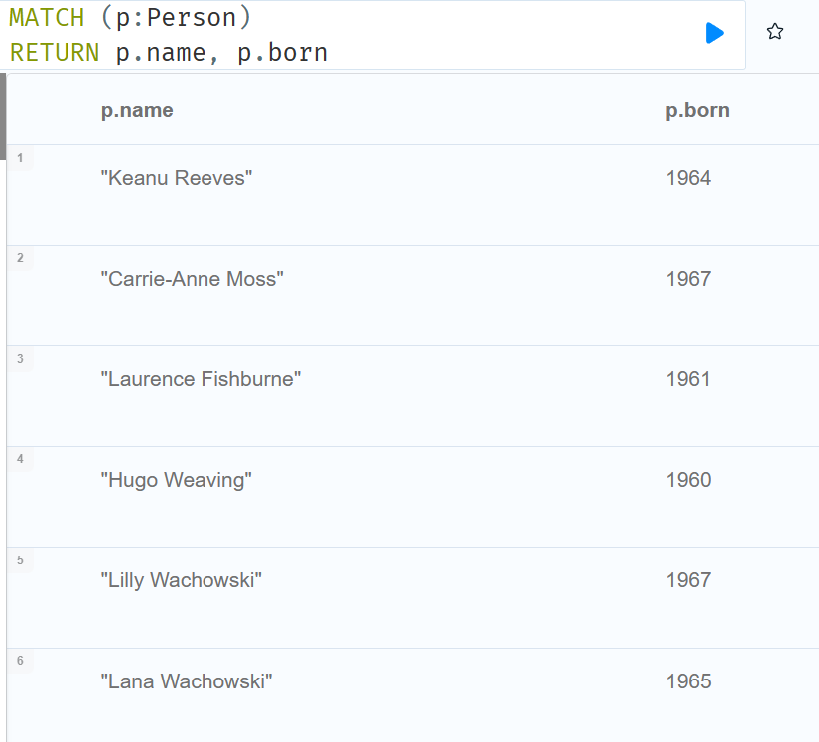

**Create a new Person node with a property name having the value of your name.**

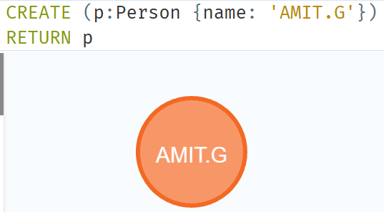

**Find the movie with title "Cloud Atlas"**

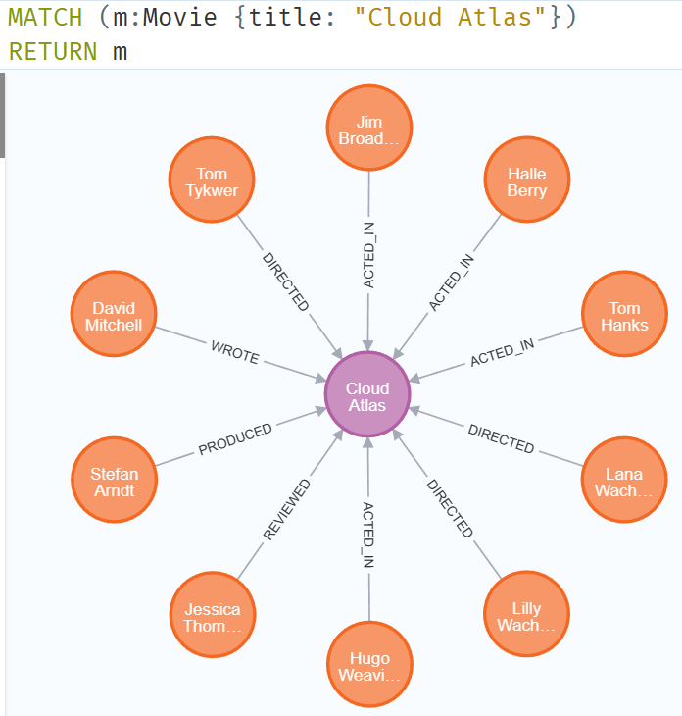

**Get all the movies that were released between 2010 and 2015.**

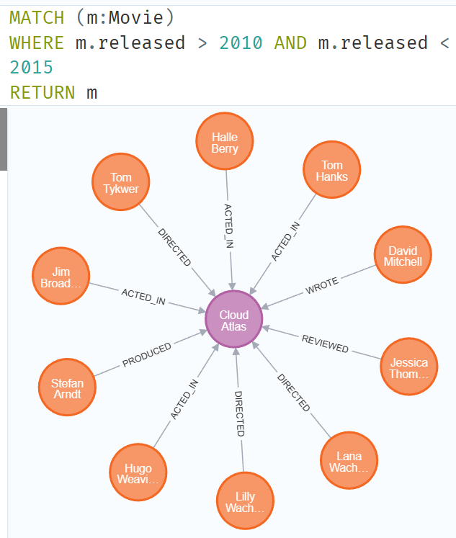

**Write a query using Merge to create a movie node with title "Greyhound". If the node does not exist then set its released property to 2020 and lastUpdatedAt property to the current time stamp. If the node already exists, then only set lastUpdatedAt to the current time stamp. Return the movie node.**

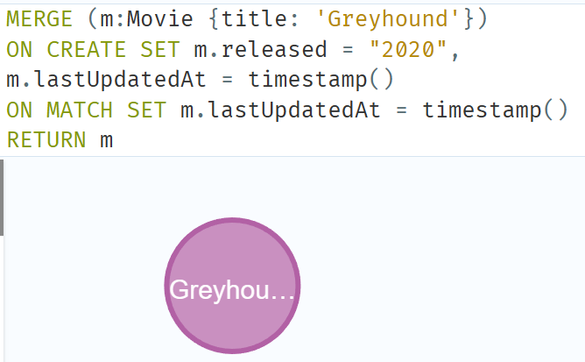

**Create a relationship :WATCHED between the node you created for yourself previously in step 6 and the movie Cloud Atlas and then return the type of created relationship**

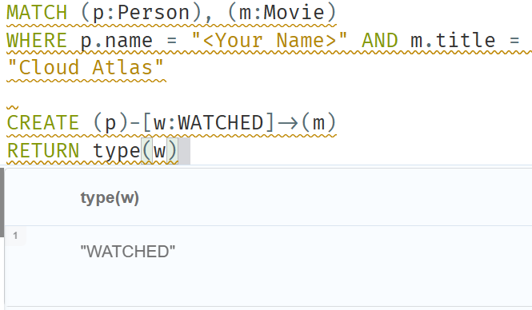

**Write a query to find the nodes Person and Movie which are connected by REVIEWED relationship and is outgoing from the Person node and incoming to the Movie node.**

